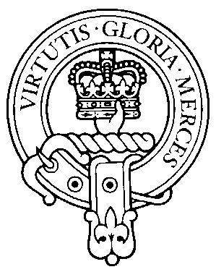
Clan Donnachaidh Society, Upper Midwest, Inc.
Membership Application Form

Mail this form with your check to:
Patricia Wilber
3087 Cheroakwood Lane
Rockford, IL 61114

LAST NAME:________________________FIRST NAME________________________
ADDRESS:______________________________________________________________
CITY:______________________________STATE:_______________ ZIP:__________
PHONE NUMBER:____________________E-MAIL____________________________

CLAN NAME AFFILIATION (such as Robertson, Duncan, etc.)___________________

Spouse's Name:___________________________________________________________

Son's Names Daughter's Names
________________________________ ______________________________
________________________________ ______________________________
________________________________ ______________________________
________________________________ ______________________________

Membership Amount Enclosed:______________________________________________

AREAS OF INTEREST
Clan History/Genealogy ____________________________________________________
Genealogical or Family Tree available to others? (Y/N)___________________________
Serving on the Clan Council ________________________________________________
Volunteering to work at the clan booth_________________________________________
Being on the social Committee_______________________________________________
Volunteering to help with a clan event ________________________________________
Write an article for the clan newsletter ________________________________________
Other __________________________________________________________________

COMMENTS ________________________________________________________________________
________________________________________________________________________
________________________________________________________________________
As a member you will receive clan newsletters including information and invitations on all upcoming clan events, voting privileges for officers at the AGM (annual general meeting) held every October, and the opportunity to be actively involved in your clan family

DOES NOT INCLUDE MEMBERSHIP TO THE INTERNATIONAL SCOTTISH SOCIETY

